Lisa Zungura
Bright_Coffee_Shops_Sales_Analysis Project

- Miro- Project Planning (Mapping)
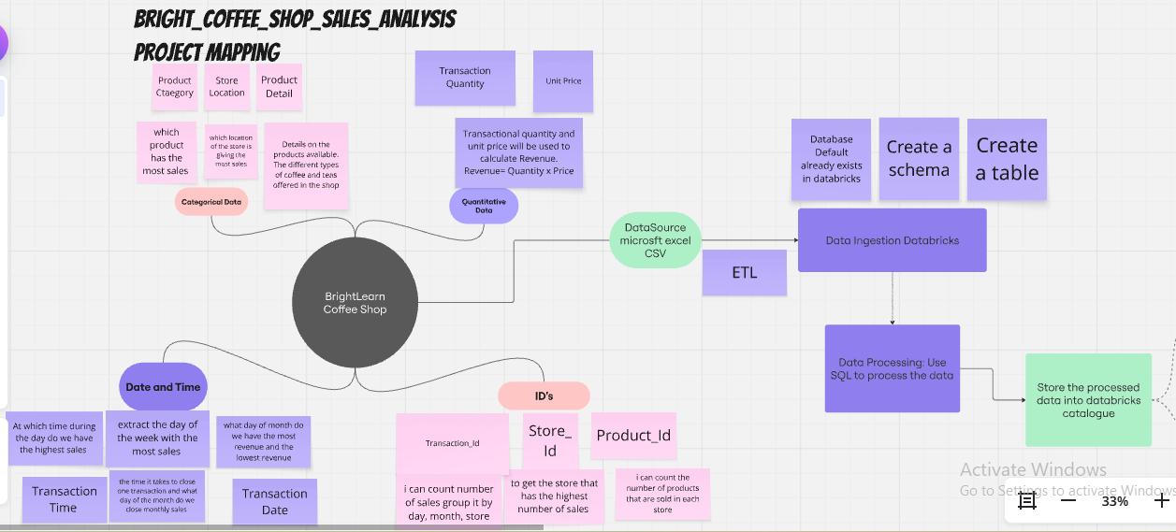

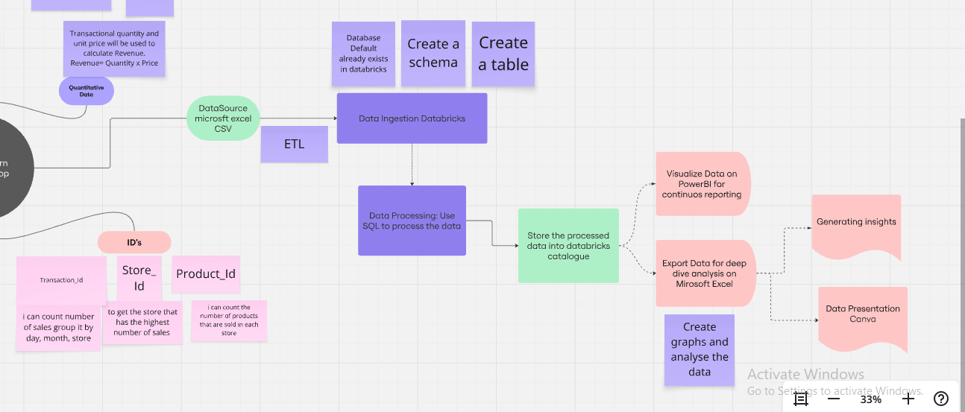

- Canva- Bright_Coffee_Sales_Analysis Timeline Ghantt Chart
